CO-OP eligibility is determined based upon the previous fiscal year’s spending. CO-OP must be approved through LSmarketing@legacysports.com in order to be reimbursed. Reimbursement is only eligible when meeting LSI’s CO-OP guidelines and prior approval. In order to be approved for CO-OP, must meet initial spending threshold.

Accrual period runs between January 1, 2017- December 31, 2017. Funds accrued will be available for use from January 15, 2018- October 31, 2018. All claims must be submitted no later than 30 days after invoice period.

CO-OP PRIOR APPROVAL PROCESS
- Complete CO-OP Prior Approval Form and Submit to LSmarketing@legacysports.com
- Include submission of advertisement that adheres to CO-OP guidelines.
- Marketing will review and approve or deny submission.
- If denied- reason and explanation will be supplied.
- LSI will indicate the percentage of funding supplied.

Important note: It is the responsibility of each distributor to monitor their own CO-OP advertising expenditures throughout the year in order to determine their exact accrual balance versus 2% of their net purchases from LSI. For the current available CO-OP allowance, contact the LSI CO-OP department. LSI reserves the right to make changes to the program at any time.

SPENDING GUIDELINES
ELIGIBLE CO-OP MARKETING TOOLS
LSI monitors CO-OP advertising to ensure brand integrity and cohesiveness.
The following tools are the platforms that are CO-OP eligible with prior approval from the LSI marketing department.
For questions, please contact: LSMarketing@LegacySports.com

PRINT (Including catalogs)
TELEVISION
DIGITAL
OUTDOOR
TRADE SHOW
SHOWROOM DISPLAYS
PROMOTIONAL ITEMS

CO-OP REIMBURSEMENT PROCESS
Submit CO-OP invoice within 30 days of activity. Invoices after 30 days of activity will not be honored.
Submit signed CO-OP Prior Approval Program Form with Reimbursement Form to: LSMarketing@LegacySports.com

Include:
- Invoice
- Copy of ads that ran during invoice period
- Signed CO-OP Prior Approval Program Form
- Reimbursement Form
- Additional required material

LSI sends payment of the approved percentage to CO-OP participant. Please allow 30 days for reimbursement.

CO-OP REIMBURSEMENT LEVELS
CO-OP Reimbursement levels are determined based on the previous year’s spend.

Your designated CO-OP Representative will review your account and confirm your 2% of Net for your CO-OP allocation. The accrual period runs between January 1, 2017 - December 31, 2017.

Level LY Spend Reimbursement
LEVEL 1 | $20,000 | 30% Reimbursement Rate
LEVEL 2 | $400,000 | 65% Reimbursement Rate
LEVEL 3 | $1,000,000 | 80% Reimbursement Rate

LSI BRANDS GUIDELINES
Use the below provided logos only. Images are to be on a white background only. Do not overlay on image. Do not place logo in shape. Use of multiple logos requires prior authorization.

On Television, Outdoor, Print, Radio or Digital: Cannot be combined with competing brands.

The brand being promoted must have equal treatment and display to dealer name or logo.
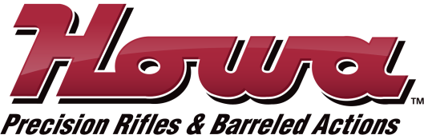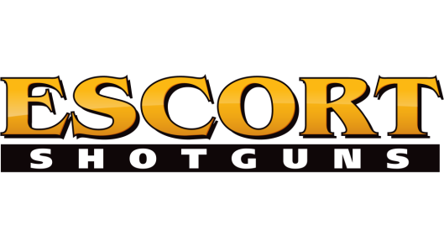
CONTACT
CO-OP DEPARTMENT
LSMARKETING@LEGACYSPORTS.COM
1-775-828-0555
1-800-5-LEGACY

